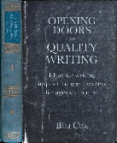
Opening Doors to Ambitious English.
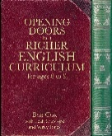
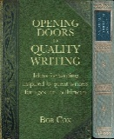
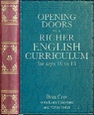
Reception and Key Stages 1,2,3
www.searchingforexcellence.co.uk
There is nothing more vital in the 2025 curriculum review than higher standards with access for all.

‘Build In, Not Bolt On’
The ‘Opening Doors’ team will support your drive for inclusive curriculum design in English with the resources and experience to tailor training to your needs. Awareness of big principles and a toolkit of strategies have been influencing a huge network of schools for over a decade. Contact Bob for queries about the team’s capacity on bobcox@searchingforexcellence.co.uk
Key-notes; coaching; blended learning; online sessions.
For classroom IMPACT on improved and creative English, pitched high and including all
You innovate, you choose routes to success, we support you with depth of knowledge and 81 units of work which are frameworks for reading and writing joy.
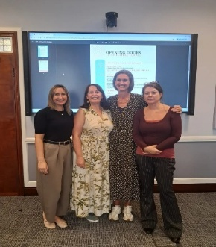
‘Opening Doors training and support had a huge impact on our school community’ Lucy Timmons, whilst executive head in Greenwich
‘Remember we can only teach writing in a meaningful way if we rebalance the creative and the technical elements to reveal its open-ended magic’ Ben Lodge, English Lead at an Opening Doors Hub, Richmond Hill Academy, Doncaster

Leah Crawford ThinkTalk – Leah Crawford – ThinkTalk.org
Julie Sargent About us — InnovatEducation
Angela Jenkins angela@angelajenkinsconsulting.com
Laura Spargo Bespoke Primary English Consultancy | Laura Spargo

