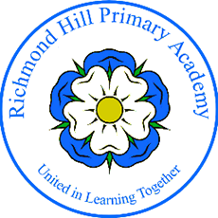
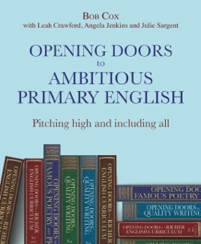
Really raising standards
in writing for all at KS2
with Opening Doors
There is nothing more vital in the 2025 curriculum review than higher standards with access for all.
The Opening Doors CPD Hub combines the expertise of Opening Doors writers and consultants with the teaching and leading expertise at Richmond Hill Primary. Pitching high and including all through:
oracy, rich texts, rigour and creativity.
Face to face

Writing at our school is now process-orientated and writing lessons now have relevance to the wider curriculum (and world) by posing deep and challenging questions from the carefully chosen texts – texts which act both as windows and mirrors.
We need to remember we can only teach writing in a meaningful way if we rebalance the creative and the technical elements of writing to reveal its open-ended magic.
Ben Lodge English Leader, RHS Primary

Online
Face to face

Face to face

Online

Cost: £300 for one delegate, £500 for two delegates from one school- this includes 3 free Opening Doors books.
For more information on the course content email leah@leahcrawford.com
To book contact: kelly.cousins@richmond.doncaster.sch.uk

