Ashby C of E Primary School’s Journey Towards an Ambitious English Curriculum

“When I look back, I am so impressed again with the life-giving power of literature. If I were a young person today, trying to gain a sense of myself in the world, I would do that again by reading, just as I did when I was young.” – Maya Angelou

At Ashby C of E Primary School, we are on a journey towards developing a rich, engaging, inspiring and of course, ambitious English curriculum. For us, it has been a good opportunity to reflect on where English developments have taken us as a sector and notably, the remnants of the National Strategies, a time where we saw extensive professional development and what became the well embedded ‘literacy hour’. We are so excited about our long-term English development and this article aims to explore further the key stages of this journey with you.

Realising a truly ambitious English curriculum means subscribing to a philosophy, a way of being, an approach that starts with challenging and high-quality literature. This can initially feel over-whelming and hard to codify. Developing the pedagogical approach to teaching English through more challenging texts requires leaders to foster a professional development culture in school where teachers acquire an infectious passion to gain the subject knowledge expertise required: There is no escaping the fact that we need to be well-read and commit to being ‘reader and writer teachers.’

There has certainly been a positive shift towards whole class guided reading approaches in recent years, with a focus on deeper textual analysis and we have welcomed the spotlight being shone on oracy. However, an inclination to teach text types and align the writing curricula accordingly, remained, with English being built around ticking the genre boxes:
- What are the key features?
- Let’s explore these in some examples (sometimes fabricated),
- Now let’s write our own and of course, let’s ensure we have a good variety of writing that ticks these boxes clearly.
Indeed, one could argue the KS2 teacher assessment framework was unintentionally guiding our children’s writing opportunities. Not all writing needs formally assessing, to be part of evidence. It was important to ask ourselves: Are we at risk of these end points driving our curriculum, are we starting from the assessment and working backwards and at what cost?

“Some primary leaders said that they are expected to gather evidence of independent writing for Year 6 writing moderation, and this is driving them to ask pupils to do too much too soon….The rush to produce extended pieces of writing independently also means that oral composition appears to be undervalued as a process.” (Telling the story: the English education subject report, March 2024)

The drive towards ensuring all schools follow an approved synthetic systematic phonics programme and an Ofsted framework which ensures early reading is ‘deep dived’ has certainly fixed our attention to getting those ‘mechanics of teaching reading’ right. Guidance from the Education Endowment Foundation has helped highlight and support teacher expertise in developing fluency and prosody. During the last few years, initial teacher training and wider teacher development through NPQs has also helped to further embed this. For us, our local English Hub also enabled us to enhance our culture of reading for pleasure and regular story time has also been given a higher priority.

When we look back and to the present, we are led towards considering what the future could look like – what do we want to achieve with our English curriculum and how do we make our carefully crafted intent statement really come to life? For us, a visit to St. Matthew’s Research School and a recommendation to explore the work of the Opening Doors team helped us to clarify what it really was we wanted to do next.

After reading 'Opening Doors to Ambitious Primary English' last summer, I highlighted some of the key things that jumped out to me. It really sang to my heart! I then bought a copy of the book for my English Lead and set about releasing him for a chunk of time once a week to read the book - whilst I read to his class (win win!). We then embarked on some good discussions about how some of the techniques could help us to put a bit more sparkle into what we were doing and designed a CPD programme, over two years, where we could introduce this to staff and embark on the journey to a truly ambitious vision for our pupils.

We had already started using Ron Berger's principles and 'An Ethic of Excellence' as part of our whole school development and there were some very strong links between Opening Doors strategies and key areas we had been focused on teaching, rehearsing and promoting in school: active listening and critique. We set about planning an INSET day to start making these links and introduced staff to some of the key approaches. We were clear with staff that we were seeking to 'play with the ideas' in year one.

Starting with what I would refer to as the 'hearts and minds’ aspect, we explored the why behind the book. Bob and the Opening Doors team are passionate about all pupils having access to quality literature and pitching high but including all, as a matter of social justice. The first key question we posed was, ‘Looking at our current offer how comfortable are we and the pupils with texts we have mapped out?’ In the wise words of Mary Myatt, ‘We are a challenge-seeking species! We like doing things that are difficult, as long as the conditions are characterised by high-challenge and low threat.’

A significant shift in our thinking came with the introduction of using 'concepts' and we spent time exploring how text types can potentially feel like shackles, holding us back from going deeper. Surrounded by stacks of books, we set about immersing ourselves in a wide range of more challenging texts and considered what key concepts we could teach and the potential for intentionally mapping out linked reading that would help deepen children’s understanding. Linked reading involves intentionally mapping out wider texts it would be beneficial for pupils to encounter around a core text; this might involve a range of genres, poetry and non-fiction. How does an author create that sense of isolation in a character? If we explore that concept of isolation across different texts, poetry, narrative, even non-fiction – the potential starts to feel vast, not limited!

The next phase involved looking at how we guide pupils through deeper textual analysis, in order that we can have high expectations and make these more challenging texts accessible to all. It is often the case that we become trapped with linear questions that become progressively harder and are similar to what we find in standardised assessments. Not only do these layouts often limit some learners, they also act as a barrier to others who may not ever get to the higher order questions nearer the end. One of the key approaches advocated by the Opening Doors team is to use a radial layout, where a central ‘big question’ can be answered through accessing a range of guiding questions around the edge (these can easily be adapted to ensure that the big question is accessible to all and further scaffolded if required). It took time, further CPD and practice for staff to feel more confident using radial layouts; it requires a high level of subject knowledge expertise. We returned to our book stacks and staff were given time to experiment with extracts, collaborating on how best to harness the power of these to build and deepen children's understanding.

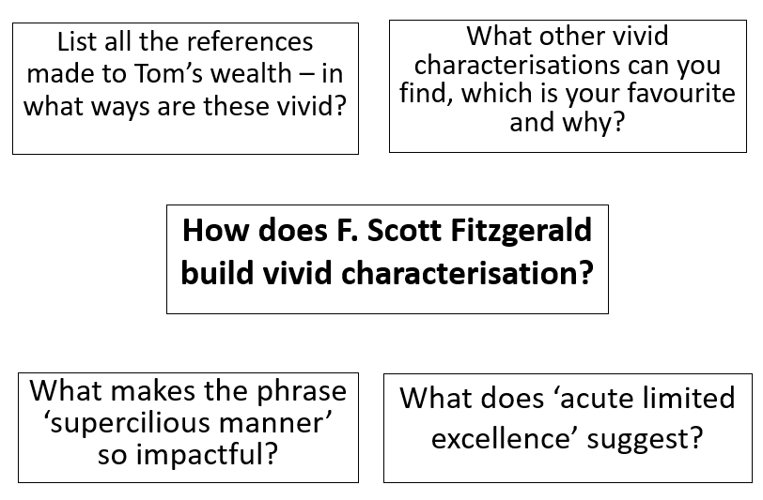

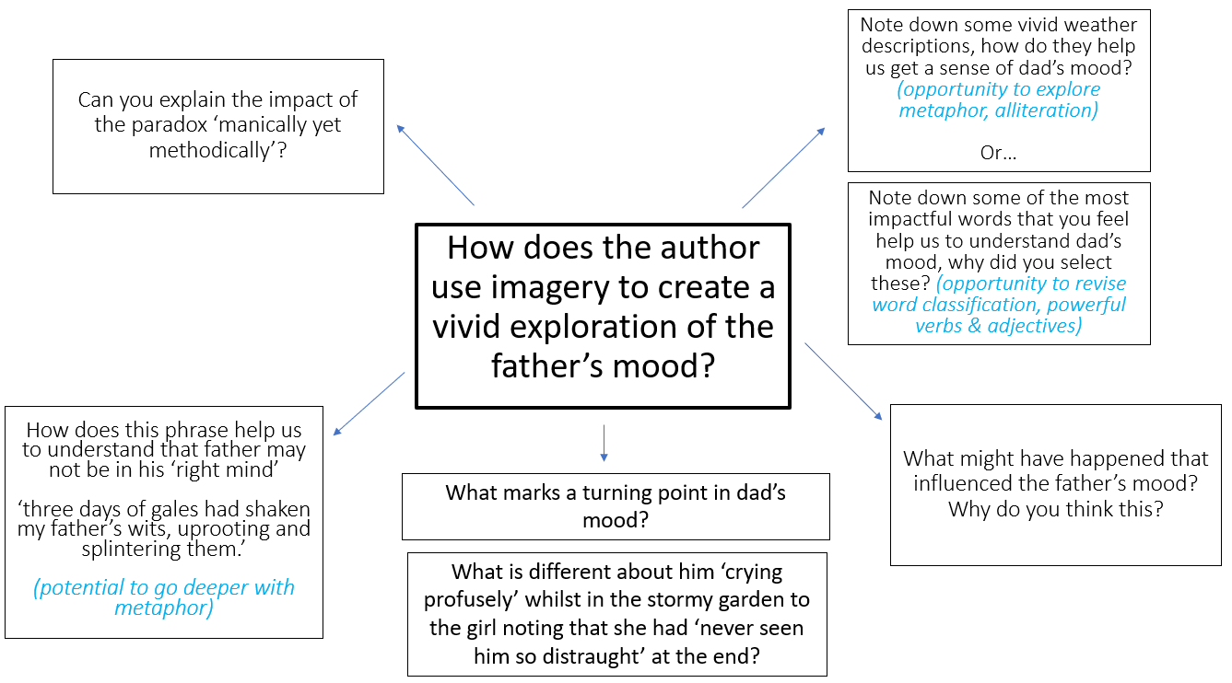

Our next focus was unlocking the potential of the ‘taster draft’, which built perfectly on our work with critique. Again, the potential shackles of a ‘text type’ and the perceived pressures of asking children to create an extended piece of writing, with very little time to really build their understanding, often results in poor quality work. Taster drafts offer children the opportunity to really craft their writing, drawing inspiration from great texts, set early in the process and providing stepping stones towards more sustained writing. They can play with techniques and new language, write in the style of a particular author and develop their own creative flair with time/word limits, so they are not flooded with too many ideas at once. In experimenting with these approaches, we have been led to consider how more attention has been given to ‘reading for pleasure’ in recent years and perhaps developing a culture of ‘writing for pleasure’, where our children are excited to share their writing voice, is something that has been neglected.

Indeed, Wyse & Hacking (2024) present an interesting new theory and model of teaching which seeks to achieve a more ‘balanced approach, noting: “Robust theory and empirical studies have increasingly pointed towards the need to systematically integrate the teaching of reading and writing for the best outcomes for both. Historically the relative neglect of writing compared to reading means that there remains a pressing need to increase attention to writing and how it might best be taught: the Double Helix of Reading and Writing offers a new possibility for such emphasis.”
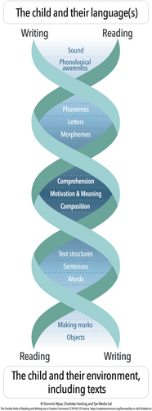

Following time to develop a shared understanding of our vision and reflecting on what has come before, we remain focused on incorporating more ambitious texts and developing mechanisms by which we can ensure that teachers are able to develop their expertise and knowledge of high-quality literature and clarity with the notion of reading and writing being collaborative acts. Initial pupil voice has shown that the children are really enjoying grappling with more complex tasks, I have been privileged to see engaged and excited learners exploring great texts and seen some very lovely writing emerging too.
Our next steps as a school and where we feel ‘Opening Doors’ strategies can really help us, is in grappling with the way in which the core components of English: speaking and listening, reading and writing, are integrated. Through focusing further on how we can create more dialogic classrooms and build on ‘learning through talk’, we will also be turning our attention towards how we better design writing tasks and in the same way we all wish to develop a ‘culture’ of reading for pleasure, reflect on how to establish and embed a ‘culture of writing for pleasure’ too.
References
Decoding, reading and writing: the double helix theory of teaching - Wyse - Literacy - Wiley Online Library
Literacy, First published: 19 May 2024, DOI: (10.1111/lit.12367)

